Cairo University Faculty of Computers and Information



**Software Engineering II**

**Software design specification document**

**2020**

**Project Team**

|  |  |  |  |
| --- | --- | --- | --- |
| **ID** | **Name** | **Email** | **Mobile** |
| 20170301 | Mounir Sabry | mounirsabry310@yahoo.com | 01155025989 |
| 20170286 | Mostafa Badr | mostafabadr19890@gmail.com | 01143030076 |
| 20170307 | Mina Botros | minabotros46@gmail.com | 01289571212 |
| 20170310 | Mina Farid | monyfaried25@gmail.com | 01277042692 |

**Eng. Esraa Salem**

Contents

Class diagram design 2

Sequence diagram design 3

Github repository link 5

# Class diagram design

# Sequence diagram design

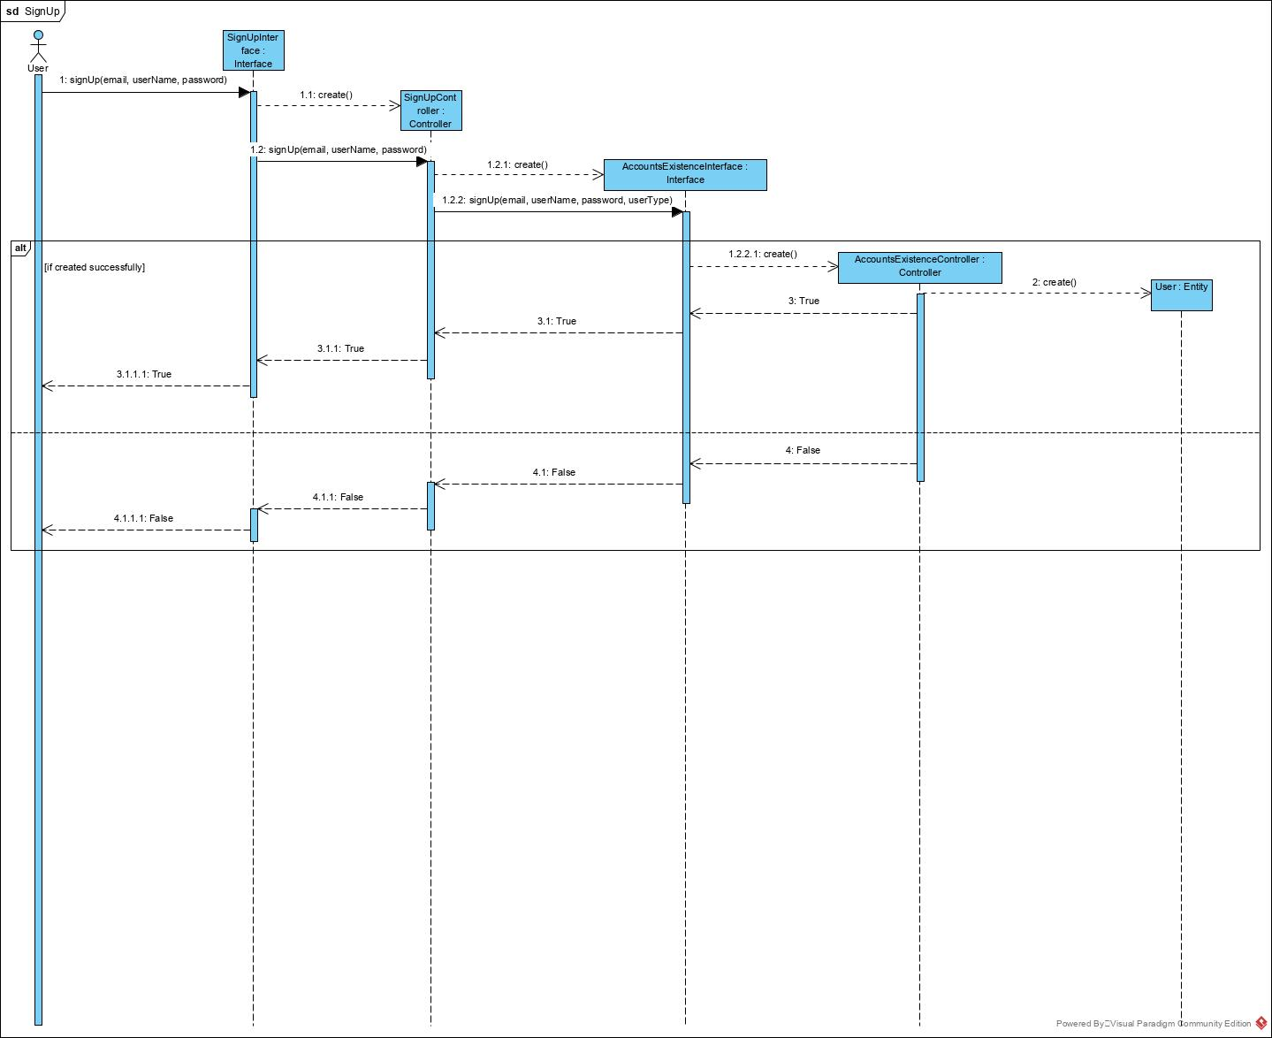

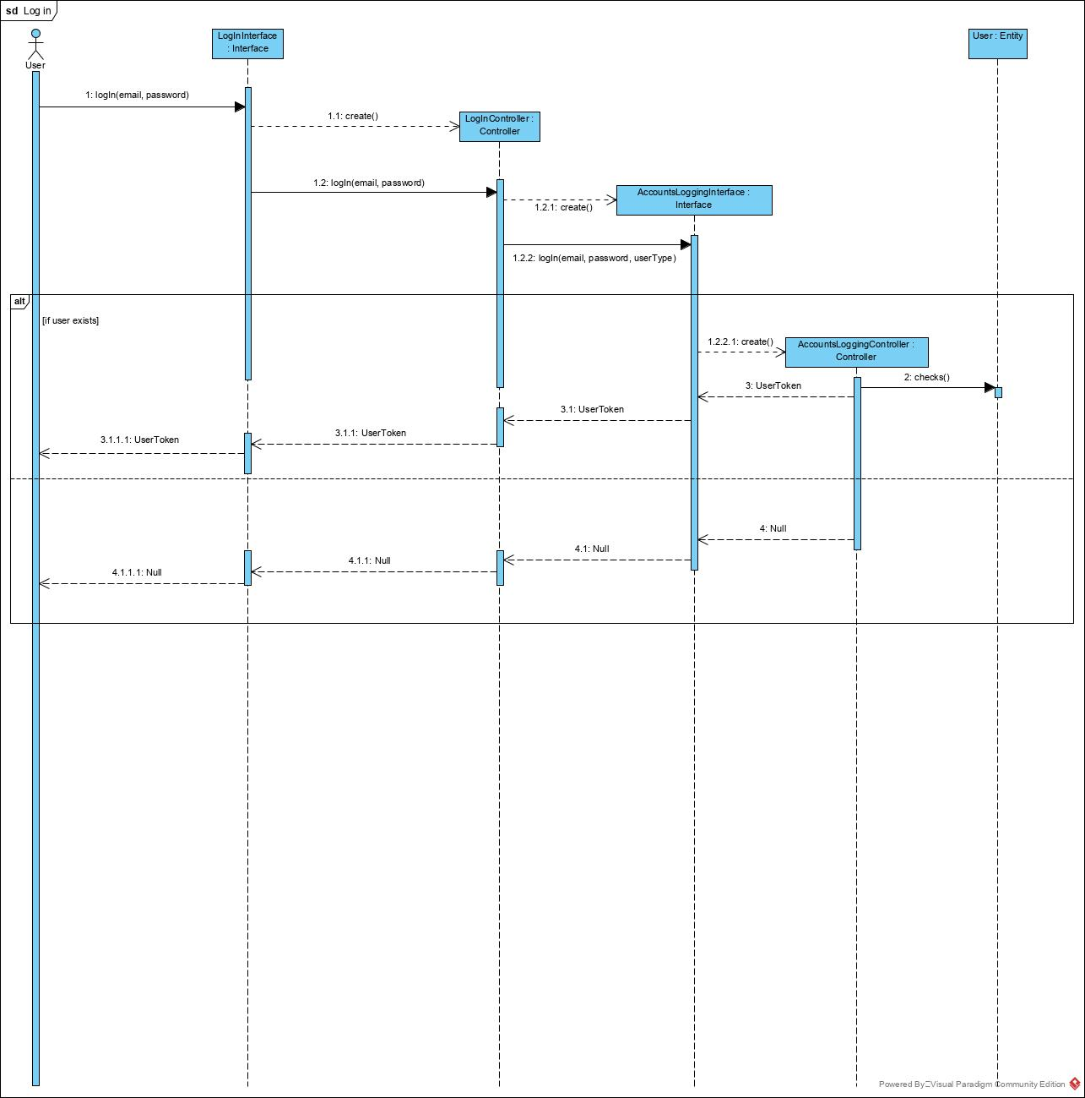

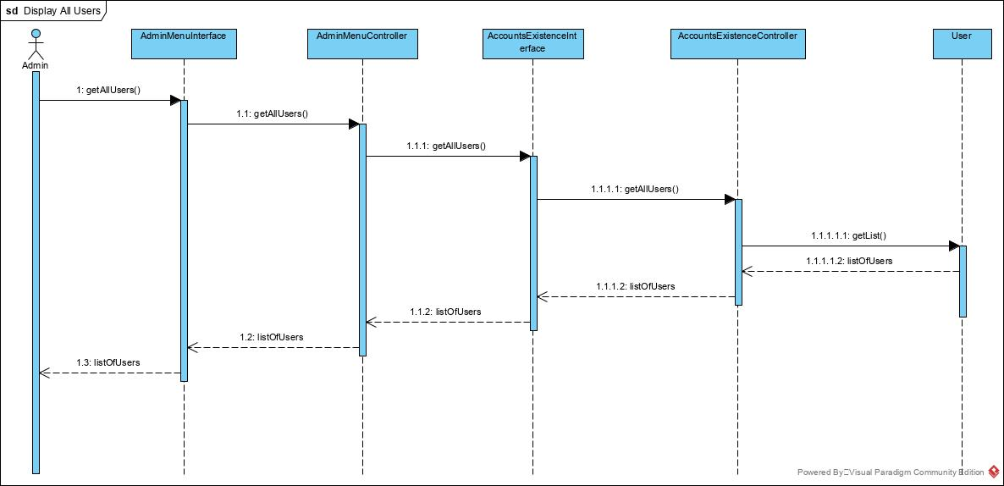

# Github repository link

* <https://github.com/mounirsabry/SE2_Project>